2023 Volume 4, Issue 1: 21–26
DOI: https://doi.org/10.48185/jcnb.v4i1.793
Review of Biological methods of AgNPs Synthesi
Motahher.A.Qaeed ^{1*,} Abdulmajeed Hendi ², A. Mindil¹, Alharthi A. Eid ¹

¹Physics Department, Faculty of Science, University of Jeddah, Jeddah, Saudi Arabia
²Department of Physics, IRC Hydrogen and Energy Storage, King Fahd University of Petroleum and Minerals, Dhahran 31261, Saudi Arabia
Received: 14.01.2023 • Accepted: 10.05.2023 • Published: 12.07.2023 • Final Version: 10.08.2023
Abstract: Recently, noble metal nanoparticle synthesis has become more advanced thanks to the growth of nanotechnology. The abundance and diversity of the biomolecules that function as capping and reducing agents in biological synthesis methods make them more advantageous than other traditional synthesis techniques in terms of cost and safety. Due to their safety and environmental friendliness, biosynthesized silver nanoparticles (AgNPs) show potential uses in a variety of disciplines. The results of reported studies on the green synthesis of Ag NPs employing various stem, fruit, and seed components have been compiled together with their effects on the morphological characteristics. This review is crucial for figuring out how to synthesize Ag NPs in a method that is regulated, less expensive, and ecologically benign.
Keywords: AgNPs; Green Synthesis; Plants; Algae; Enzymes; Fungi
- Introduction
In contrast to bulk matter, nanotechnology creates nanoparticles (NPs) and nanoproducts with innovative size-related physicochemical features that are likely employed in many different commercial products throughout the world.[1]. The scientific world has compiled impressive advancements in the domains of nanotechnology and nano-science during the previous several years. [2]. Nanoparticles have superior properties based on their structure, shape, and size rage between1and 100 nm). Nanoparticles can be broadly classified into two types: organic nanoparticles and inorganic nanoparticles. An inorganic semiconductor nanoparticles such as (ZnS ,ZnO, CdS), while metal nanoparticles such as (Ag, Al, Cu, Au), as the magnetic nanoparticles (Ni, Co, Fe), and the organic nanoparticles are essentially carbon nanoparticles like carbon nanotubes, fullerenes, quantum dots. Silver (Ag) and Gold (Au) NPs are immediately gaining some interest due to their excellent properties and flexibility[3]. In this review, AgNPs are noted for their unique and distinctive excellent physicochemical properties, including surface-enhanced Raman scattering, high thermal and electrical conductivity, chemical stability, catalytic activity, biological properties[4] and nonlinear optical behavior[5]. The outstanding properties are crystalline, size, shape, structure and composition are superior to those of the bulk materials form [6, 7]. The unique features possess ability to be applied in many potential applications, including consumer, renewable energy, biomedical devices, remediation, medicine, food, environmental cosmetics, and industrial purposes[8, 9].
In recent years, the NPs produced by green synthesis has attracted much attention. This is because; natural resources, including microbes, enzymes and plant extracts possess proven to be a good substitute reagents in nanoparticle fabrication. The use of green materials offers various benefits, including low energy consumption, the absence of any harmful chemicals, and moderate operating conditions e.g., temperature and pressure [10]. As a result, green synthesis methods for creating nanoparticles have been developed employing a variety of species, including molds, yeast, bacteria, algae, and plant extracts. [11].
Metal nanoparticles have distinct thermal, physical, chemical, and optical characteristics in comparison with metallic elements in the bulk form because of their large surface area-to-volume ratio. [12]. Thus, Due to their special qualities, nanoparticles with a diameter of less than 100 nm are appropriate for a wide range of applications [13]. Major microbiological species including bacteria, fungi, and viruses are known to be extremely poisonous to silver and its compounds. [3, 14, 15]. The mechanism of silver fungicidal and fungicidal activity is not exactly understood, but may be that silver inhibits cell transmission and also causes cell lysis[16].
The higher the ratio of surface area to volume of AgNPs, is the more remarkable their antimicrobial and physicochemical properties[17]. The antimicrobial properties of silver make it an interesting option for the applications in water treatment, catalysis, mirrors, optics, air treatment, photography, food packaging, medicine, dentistry, electronics, clothing, and many other areas[16, 18].
AgNPs have been synthesized utilizing a long range of methods, including chemical, physical, and environmentally friendly (biological) ones. All of these techniques include the use of a reducing chemical to convert silver ions into silver as well as nucleation and growth procedures to create stable nanoparticles [19, 20]. It is feasible to create particles with the necessary qualities using a variety of chemical and physical processes can been used to create nanoparticles. However, it is not a promising approach to utilize pricey and harmful compounds as lowering and stabilizing agents [21, 22]. Plant extracts and microorganisms have been lauded as a promising alternative synthesis technique.
It is anticipated to be applicable to A number of plant metabolites, including proteins, sugars, alkaloids, phenolic acids, terpenoids, and polyphenols, are crucial for the bioreduction of silver ions into silver nanoparticles[23]. acalyphaindica[24], mangroves[25], Arbutus unedo [26], Tribulus terrestris [27],use of Rumex hymenosepalus [28], Eucalyptus chapmaniana[29], Eucalyptus chapmaniana[3] to create AgNPs, previously been revealed. Polysaccharides, The primary elements of the plant extracts are polyol components and water-soluble heterocyclic compounds, which play a key role in the stability of the generated nanoparticles and the reduction of silver ions. Regarding the effectiveness of the AgNPs manufacturing process, it is vital to consider the kind of organic compounds in the crude leaf extract, the concentration of initial silver ion ions, temperature, and the type and concentration of leaf extract pigments. These factors all play a role in the green synthesis of AgNPs using plant extracts [30]. When compared to physical and chemical processes, plant extracts are more affordable and ecologically friendly, and they may be used to create nanoparticles that are safe for human usage [31]. This process offers an affordable and worthwhile option for the large-scale manufacture of AgNPs. In addition, plant extracts have the potential to act as both reducing and stabilizing agents in nanoparticle synthesis[23]. By avoiding the identification, isolation, and maintenance processes, the use of plant extracts for nanoparticle production may be preferable over microbial methods.
Silver nanoparticles (AgNPs) may be created using "bottom-up" and "top-down" methods, as demonstrated in the Fig.1 below. The "bottom-up" approach entails the creation of AgNPs through chemical and biological processes that involve self-assembling atoms into other nuclei that develop into nanoscale-sized particles (Fig.1), as opposed to the "top-down" approach, which involves the size reduction of bulk materials through lithographic techniques (such as grinding, milling, sputtering, or thermal/laser ablation) (Fig.1). Chemical reduction is frequently employed in the "bottom-up" technique to create silver nanoparticles. The silver ions (Ag⁺) are reduced in aqueous and non-aqueous solutions using organic or inorganic reducing agents, such as sodium citrate, sodium borohydride (NaBH₄), elemental hydrogen, ascorbate, N,N-dimethylformamide (DMF), and polyethyleneglycol copolymers. Capping agents are also employed to stabilize the nanoparticles. This technique has a significant benefit because it enables the rapid acquisition of vast amounts of AgNPs. This procedure' significant drawbacks include the usage of hazardous chemicals and the production of unfriendly byproducts[32, 33].
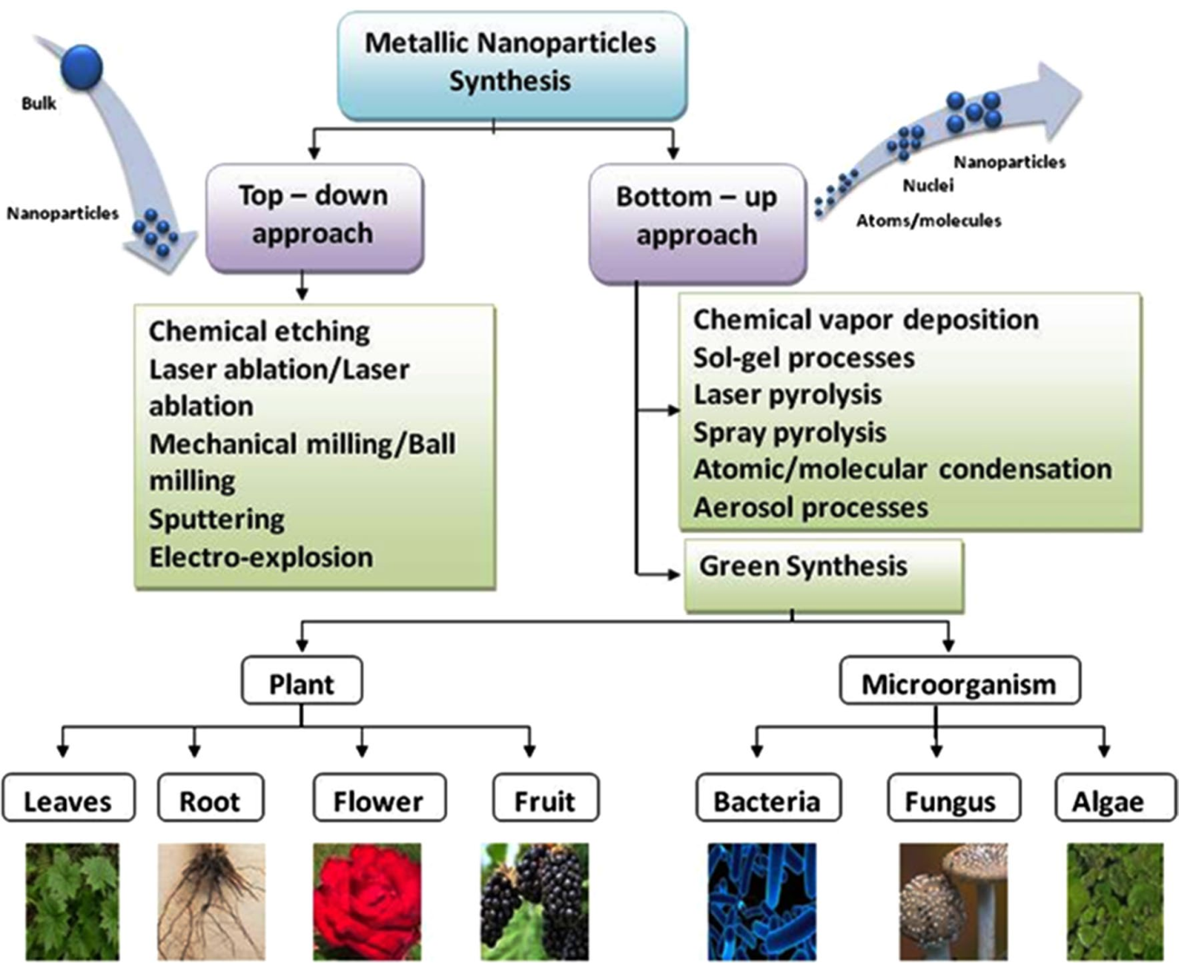
Figure 1. (1) Green Synthesis methods of AgNPs adopted from[34]
Green synthesis methods of AgNPs
Biological method: in this method, The use of microorganisms including bacteria, fungus, yeast, and actinomycetes in the manufacture of metal nanoparticles has enormous promise. It is a method that is beneficial to the environment. Proteins, enzymes, polysaccharides, amino acids, and vitamins found in microorganism extracts may function as reducing and capping agents during the formation of AgNPs. Thus, microbes may contribute to the provision of a large number of nucleation sites and the creation of the circumstances necessary to produce highly distributed nanoparticle systems. They may also immobilize nanoparticles by inhibiting their agglomeration and provide a viscous medium. These microorganisms have recently been recognized as possible eco-friendly Nanofactories. Numerous academics have investigated how microbial resources are used in the production of silver and gold nanoparticles [35-37]. Additionally, these extracts have been shown to have anti-HIV, antifungal, larvicidal, antibacterial, anti-inflammatory, antidiabetic, antioxidant, and snake venom neutralizing properties[38].
Biological method of AgNPs synthesis using bacteria
Extracellular and intracellular manufactoring of inorganic materials via bacteria is a promising biofactory for the production of precious metal nanoparticles such as gold and silver. Despite evidence that silver nanoparticles are biocompatible, certain bacteria are resistant to silver [39]. These bacterias can collect silver in their walls of cell and are industrially suggested for utilize in the recovery of silver from raw materials [40] A number of bacteria that could be used to synthesize AgNPs shown in (Table. 1).
Table 1. Biological method of AgNPs synthesis using bacteria adopted from [41]
Type of Bacteria | Intracellular or  Extracellular | Precursor | Size (nm) | Shape | Ref
Marine  Ochrobactrum spp. | Intr | AgNO3 | 38–85 | Spherical | [42]
Exiguobacteriumm  exicanum | Extr | AgNO3 | 5–40 | Spherical  and cubic | [43]
Shewanella  oneidensis | Extr | AgNO3 | 4 1.5 | Spherical | [44]
Lactobacillus spp. | Extr and intr | AgNO3 | 2–20 | Spherical | [44]
Lactobacillus sp.  HG-C3 | Extr | AgNO3 | 8–25 | and spherical | [45]
Serratia  nematodiphila | Extr | AgNO3 | 10–31 | Spherical and  crystalline | [46]
Pseudomonas  putida NCIM 2650 | Extr | AgNO3 | 70 | Spherical | [47]
Bacillus  methylotrophicus | Extr | AgNO3 | 10–30 | Spherical | [48]
Rhodococcus spp. | Intr | AgNO3 | 5–50 | Spherical | [49]
Vibrio  alginolyticus | Extr and intr | AgNO3 | 50–100 | Spherical | [50]

Klaus et al [51] studied AgNPs synthesis using the Ag-resistant Pseudomonas stutzeri AG259 strain. As a result, they reported a large accumulation of AgNPs reach to 200 nm [51], Moreover, research on AgNP synthesis utilizing Bacillus licheniformis was done in 2008 [52]. In this study, AgNO₃ solution was imparted to B. licheniformis biomass and the a brownish color shown was confirmed that AgNPs were formed within an average diameter of 50 nm and stabilized by nitrate enzymes Nanda and Saravanan[53] further said that Staphylococcus aureus culture supernatants were used to produce AgNPs. Their research revealed that all types of Enterobacteriaceae produce AgNPs at a high rate in culture supernatants [53]. Suresh et al [54] utilized a bacterium (Shewanella oneidensis) with the ability to reduce metals and biosynthesized silver nanoparticles by incorporating them into silver nitrate solution. The outcome result was almost monodisperse AgNPs with spherical shape, as the size 2 - 11 nm, with excellent properties like hydrophilic, stability, and possess a large surface area [54]. Regarding to another research [55], stability of AgNPs occur were fabricated via the airborne bacterium Bacillus sp. and silver nitrate. The sizes obtained were reported to be between 5 and 15 nm when the biogenic of NPs was investigated between the inner and outer cell membranes of bacterial cells. Considering a report [56], By reducing aqueous Ag+ in a variety of bacterial cultures (Klebsiella pneumoniae, Enterobacter cloacae, and Escherichia coli), AgNPs are created. The findings demonstrated that AgNPs are produced within 5 minutes following the addition of Ag ions to the cell filtrate, demonstrating a very quick rate of synthesis. Sintubin and other [57] used Lactobacillus spp. in the production of AgNPs as a capping and reducing agent. Different kinds of lactic acid bacteria were utilized in this work to gather and then decrease Ag+.
Biological method of AgNPs synthesis using fungi
Metal NP synthesis is possible via fungi. This is because of their highest binding capability, capacity for metal bioaccumulation, and tolerance of cellular absorption [58]. Fungi secrete sufficient enzymes that can reduce AgNO₃ solutions in a variety of ways, which can be used to synthesize NPs [59].Kumar et al[60] examined the rational use of enzymes possessed by fungi. The following is an in vitro enzymatic process for producing AgNPs: Nitrate reductase and phytochelatin are used to process NADPH (nicotinamide adenine dinucleotide phosphate) [60]. Purified nitrate reductase from the fungus Fusarium oxysporum was coupled with NADPH in vitro. According to their research, hydroxyquinoline serves as an electron shuttle for silver, a capping peptide was used to further stabilize the silver hydrosol, which had a size range of 10 to 25 nm. It has been reported that Trichoderma viride contains biocomponents useful for the extracellular biosynthesis of Ag; micrographs demonstrate that the produced AgNPs have a variety of morphologies, including rod-like and spherical, and the obtained NPs range in size from 5 to 40 nm [61]. In another study, Naqviet et al [62] shown that producing AgNPs with antibiotic-incorporated A. flavus increased their biocidal effectiveness against multidrug-resistant bacteria [62]. Ahmad et al[61] It has also been shown that water-soluble Ag+ ions are reduced in solution by an enzymatic mechanism to create a very stable Ag hydrosol when they come into contact with Fusarium oxysporum. The generated NPs are detected in the 5–15 nm range and are stabilized in solution by bacteria-secreted proteins [61]. Extracellular synthesis from Aspergillus fumigatus produces monodisperse AgNPs and is shown to be extremely quick [2].
Regarding to research [63] AgNPs with spherical shape were synthesized used Aspergillus terreus and reported that they have a diameter of 1-20 nm [63]. The extracellular production of AgNPs using F. oxysporum and their antimicrobial impact on the textile fabrics were also studied [64], and from work [37] they claimed that monodisperse AgNPs could be realized with the fungus Aspergillus flavus. In this research, (TEM) measurement shown that the size of NPs appeared to be in the range of 8.92 ± 1.61 nm [37]. Additionally, Balaji et al. investigated the extracellular synthesis of AgNPs using Cladosporium cladosporioides [65], who found that the size of synthesized NPs measured via TEM was between 10-100 nm [65]. In summary, we can say that the walls of the cell microorganisms used in biological synthesis play an important role in the formation of NPs in the cell. The interaction of positively charged metal ions with the negatively charged cell wall results in the electrostatic biological reduction of metal ions to NPs [66]. As shown in Table 2, there are numerous fungi available for the synthesis of AgNPs.
Table 2. Biological method of AgNPs synthesis using fungi adopted from [41]
Type of Fungi | Intracellular/Extracellular | Precursor | Size  (nm) | Shape | Ref
Aspergillus  niger | Extr | AgNO3 | 1-20 | Spherical and  Poly-dispersed | [67]
Trichoderma  harzianum | Extr | AgNO3 | 34.77 | Ellipsoid and  Spherical | [68]
Fusarium  acuminatum | Extr | AgNO3 | 13 | Spherical | [69]
Penicillium  fellutanum | Extr | AgNO3 | 5-25 | Spherical | [70]
Aspergillus  clavatus | Extr and intr | AgNO3 | 10-25 | Poly-dispersed  and Spherical | [71]
Fusarium  oxysporum | Extr | AgNO3 | 10-25 | Not reported | [60]
Aspergillus  flavus | Extr | AgNO3 | 8.92  ±1.61 | Mono-dispersed | [37]
Schizophyllum  commune | Extr and intr | AgNO3 | 51-93 | Spherical | [72]

Biological method of AgNPs synthesis using Plants
Preparation of metal nanoparticles via plants (plant extracts, non-functional plant tissues, and living plants) is a promising part of the biosynthetic process. It is known that the plants possess the ability to potential to reduce metal ions at the nanoparticle surfaces and in various tissues and organs away from ion permeation sites [23]. Biomolecules (Biomolecules present in plant extracts, including amino acids, enzymes proteins, polysaccharides, vitamins, and some organic acids, such as citric acid, can maybe reduce metal ions. In this context, plant extracts are employed for the biological reduction of metal ions from their nanoparticles, an in vitro method that has been effectively established in recent years. extracts different plant components, such leaves and flowers Fruits and seeds.
Plant metabolites: The plants are made up of a variety of plant metabolites, including terpenoids and polysaccharides, Alkaloid, proteins, phenolic acids, and polyphenols all contribute significantly to the bioreduction of metal ions into nanoparticles [23]. Terpenoids are a diverse group of plant-based organic polymers of five-carbon isoprene units that possess potent antioxidants[23]. Flavonoids are a large group of polyphenols consisting of several catigories including flavonols, anthocyanins, chalcones, isoflavonoids, and flavanones, which can efficiently bind metal ions and transform them into nanoparticles. Flavonoid groups are also capable of forming nanoparticles[23]. Sugar is also utilized to create metal nanoparticles in plant extracts. Because their free aldehyde groups can function as reducing and capping agents shown in Fig.2, agents, they are recognized as monosaccharides like glucose. The kind of sugars and the quantity of each component monosaccharide are very important factors[23].

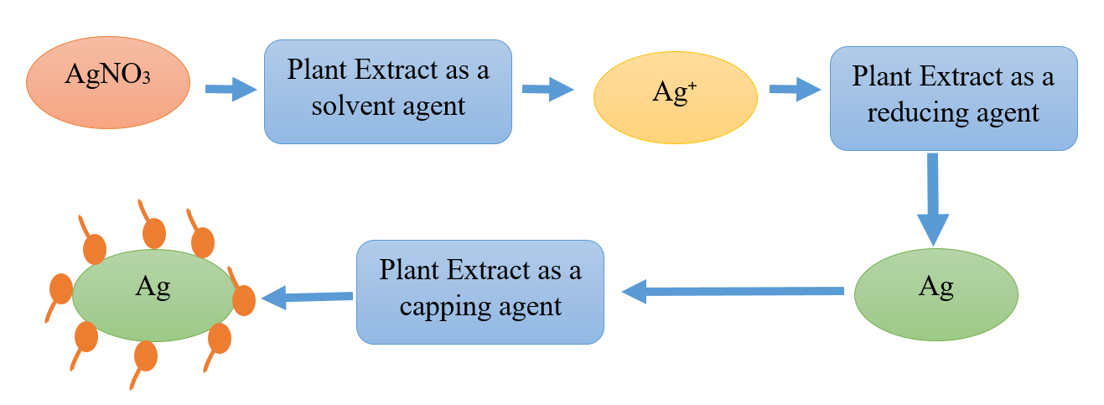
Figure 2. Plant extract work as solvent, reduction and capping agent in green synthesis

Different amino acid-containing proteins have the ability to diminish a number of metal ions, resulting in nanoparticles. In green synthesis, plant extracts are usually utilized to synthesize silver nanoparticles. The plant extracts are mixed with silver nitrate to form silver nanoparticles. However, several factors, such as the nature of the reducing agent (e.g., plant secondary metabolites) shown in Fig. 3, the method of stirring the solution while adding AgNO3, the dropping or direct addition of AgNO₃ to the series, the concentration of plant extract used, the concentration of AgNO₃ solution, the time interval, light or radiation intensity, reaction time, temperature, and pH, can affect the synthetic process.

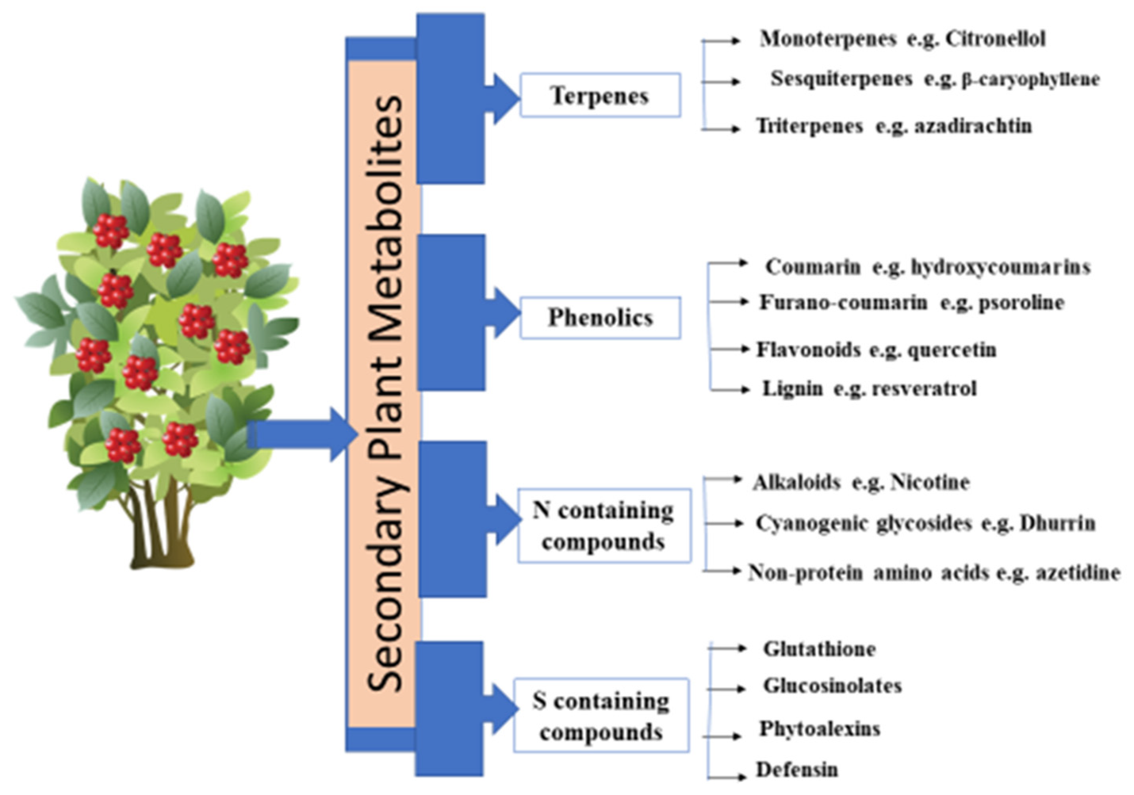
Figure 3. Types of secondary metabolites adopted from [73]

Table 3. (3) Green synthesis of AgNPs using Plants adopted from[74]
References | Size  (nm) | Morphology | Plant  part used | Plant origin | Sr.  no.
[75] | 2-6 | Spherical | Leaf | Cycas | 1
[76] | 15-50 | Spherical | leaf | Polyalthia longifolia | 2
[77] | 75 | Spherical | Stem | Citrullus colocynthis  (Bitter Apple) | 3
[78] | 12 | Spherical | Fruit | Ananas comosus | 4
[79] | 14 | Spherical | Rhizome | Dioscorea oppositifolia L. | 5
[80] | 20-40 | Cubical | Leaves | Mulberry | 6
[81] | 4-18 | Spherical | Berry | Solanum xanthocarpum L. | 7
[82] | 3-44 | - | Whole  seaweed | Marinmacroalga  Chaetomortha linum | 8
[83] | 4-14 and  2-16 | Spherical,  nanotrangles,  hexagonal | Leaf | Eruca sativa and  Spinacia oleracea | 9
[84] | 04-12 | Spherical | Root | Black Carrot  Daucus Carota | 10
[85] | 20-25 | Spherical | Leaf | Olive leaf | 11
[86] | - | Spherical | Flower | Taraxacum  officinale | 12
[87] | 4-48 | Spherical | Stem bark | Syzygium alternifolium  (Wt.) Walp | 13
[88] | 10-40 | Spherical | Fruit | carambola | 14
[89] | 10-15 | Spherical | Leaf | Cinnamomun  Tamala | 15
[90] | 80 | Spherical | Leaf | crotolaria retusa | 16
[91] | 10-12 | Spherical | Leaf | Wrightia tomentosa | 17
[92] | 30-60 | Spherical | Aerial  part | Lippia nodiflora | 18
[93] | 10-60 | Spherical | Leaf | Saccharum officinarum | 19
[94] | 29 | Spherical | Leaf | Pelargonium/ Geranium | 20
[95] | 30-40 | Spherical | Leaf | Ricinus communis  var. carmencita | 6
[95] | 21-60 | Hexagonal | Leaf | Zizyphusspina Christi | 7
[96] | 17 | Spherical | Fruit | Citrullus lanatus | 10
[97] | 16-20 | Spherical | Fruit | Carica papaya | 12
[98] | 23 | Spherical | Seeds | Peganum harmala | 14
[99] | 35 | Spherical | bark | Butea monosperma | 24
[100] | 7.2 | Spherical | Flower | Alcea rosea | 26

Silver Nanoparticles utilizing as Antimicrobial agent
Since they have the potential to combat resistant antibiotics, AgNPs are frequently utilized as antimicrobial agents. They successfully combat both gram-positive and gram-negative bacteria. AgNP is said to bind with the bacterial cell wall, pass through it, and seriously disrupt cellular function, leading to cell death [101-103]. AgNPs' antibacterial activities are influenced by a number of physico-chemical factors, including shape, size, surface charge, concentration, and colloidal state [104]. The physico-chemical characteristics essentially rely on the process employed to create the nanoparticle. Table 4 lists each algae's contribution to the antibacterial activity of AgNPs.
Table 4. (4) Silver Nanoparticles utilizing as Antimicrobial agent adopted from[105]
Fugi Type | Size of NP(nm)  shape | Volume of NP used | Antimicrobial activity (zone of inhibition) | Ref
Padina  tetrastromatica | 14 spherical | (30, 60 , 90) μl | Bacillus sp., Pseudomonas sp., Bacillus subtilis, Klebsiella planticola | [106]
Sargassum  polycystum | 5-7 spherical | 100 μl | Pseudomonas aeruginosa, Klebsiella, Pneumoniae, Escherichia coli,  Staphylococcus aureus | [107]
Gracilaria corticata | 18-46 spherical | 30 ml | C. albicans, C. glabara | [108]
Gelidiella acerosa | 22 spherical | 50 μl | Humicola insolens, Fusarium dimerum, Mucor indicus, Trichoderma reesei | [108]
Enteromorpha  flexuosa | 2-32 circular | - | B. subtilis, B. pumulis, E. faecalis, S. aureus, S. epidermidis, E. coli, S. cerevisiae,  C. albicans | [109]
Sargassum wightii | 8-27 spherical | (30, 60 , 90) μl | Staphylococcus aureus, Bacillus rhizoids, E. coli, Pseudomonas aeruginosa | [110]
Turbinaria conoides | 2-17 spherical | 50 ml | Salmonella, E. coli, S. liquefaciens, A. hydrophila | [111]
Ulva fasciata | 50 spherical | 20 μl | C. albicans, C. glabrata | [112]

Biological method of AgNPs synthesis using algae
A class of autotrophic organisms of economic and ecological significance is algae. They are single-celled or multicellular creatures that may exist in a variety of environments, including freshwater, saltwater, or moist rock surfaces. Microalgae (microscopic) and macroalgae (macroscopic) are the two distinct types of algae. They are essential in applications including forestry, pharmaceuticals, cosmetics aquaculture. They are a significant orgin of a number of industrial goods, including as biodiesel and natural dyes[113].
"Phyconano- technology" refers to the area of nanoscience that use algae in the production of nanoparticles. It belongs to a very young branch of nanoscience. Algae are utilized in the production of nanoparticles because they can grow at low temperatures, have a great capacity to collect the metals, are simple to manage and culture, and are less harmful to the environment[114]. The most popular categories of algae utilized to create silver nanoparticles are Chlorophyceae, Phaeophyceae, Cyanophyceae, and Rhodophyceae [113]. Fig.3. illustrate the easy method to synthesis AgNPs using algae and Table 3 shows the sizes and shapes of the AgNPs produced by several species of algae, along with the NPs themselves.Shape, size, stability, and other physical and chemical characteristics of NPs can all be changed by a number of different factors. Algae are frequently used these days for the production of nanoparticles. Algae are widely used because of their great ability to absorb metals and decrease metal ions, relatively inexpensive manufacturing costs, and—most importantly—large-scale synthesis of nanoparticles[115, 116].
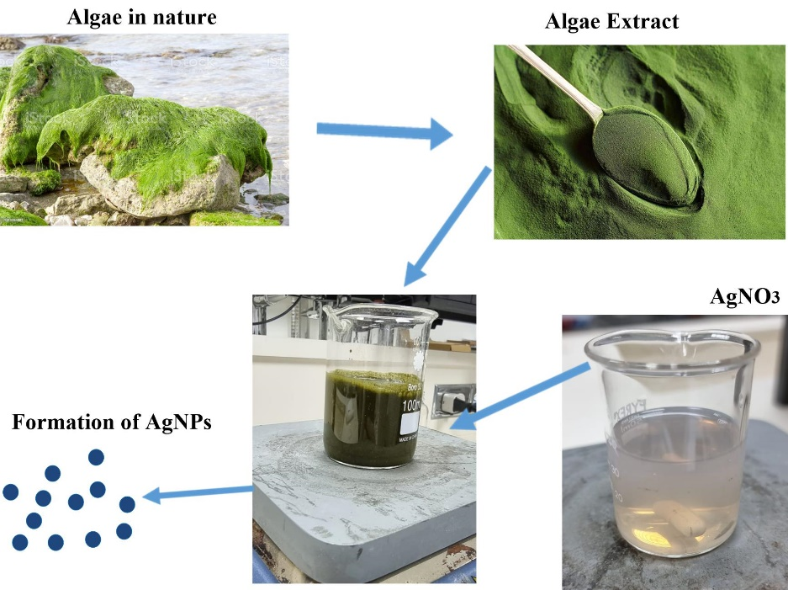
Figure 4. Synthesis AgNPs using algae as a green synthesis

Their greater capacity to withstand extreme climatic conditions than other microbes is an additional intriguing characteristic[117]. Algae biomass may be utilized to create nanoparticles both alive and dead, which is why these systems are often referred to as "Bionanofactories" [118]. The time needed for the creation of silver nanoparticles is another benefit of employing algae. Compared to other microorganisms, algae-mediated synthesis goes more quickly. While Caulerpa racemose generated nanoparticles in approximately 3 h [119], E. coli needed around 60 h to synthesis AgNPs [120]. Algae produce hydrophilic surface groups like sulphate, carboxyl, and hydroxl that allow their produced silver nanoparticles a special range of applications. Because algae do not produce anything on their own, they can be employed in medicinal treatments.
Table 5. (3) Biological method of AgNPs synthesis using algae adopted from[105]

Algae | Type | Intracellular & extracellular | Size of Np (Nm) | Shape | Temp(C°). | Reference
Cyanobacteria | Microcoleus | Extr | 44–79 | Spherical | RT | [121]
 | Phormidium willei | Extr | 100–200 | Spherical | 25 | [122]
 | Plectonema boryanum | Intr & Extr | 1–15,  1–40,  5–200 | Octahedral& Spherical | 25, 60,  100 | [123]
 | Spirulina platensis | Extr | ≈12 | Spherical | 25 | [124, 125]
Microalgae | Chlamydomonas reinhardtii | Intr & extr | 5–15(in vitro) ,  5–35 (in vivo) | rectangular /Round | RT | [126]
 | Chlorella vulgaris | Intr | ≈ 10 | Spherical | 28 | [127, 128]
 | Nannochloropsis oculate | Intr | ≈ 19 | Spherical | 28 | [129]
Macroalgae | Caulerpa racemose | Extr | 5–25 | triangular /Spherical | RT | [119]
 | Codium capitatum | – | ≈ 30 |  | RT | [130]
 | Ulva fasciata | Extr | 28–41 | Spherical | RT | [131]
 | Padina gymnospor | – | 25–40 | Spherical | 30 | [132]
 | Padina pavonica | Extr | 45–64 | Spherical | - | [133]
 | Gelidiella acerosa | – | 22 | Spherical | RT | [108]
 | Gracilaria dura | – | 6 | Spherical | 25,60 & 100 | [134]
 | Hypnea musciformis | – | 40–65 | Spherical | RT | [135]

Biological method of AgNPs synthesis using enzymes
There are several kinds of enzyme-mediated nanoparticle synthesises (Table 4). By nature, enzymes catalyze synthesis but do not participate in reactions, and they occasionally may act as stabilizing and reducing agents. Whole enzymes or amino acids that are liberated following an enzyme's denaturation may potentially catalyze a reaction under specific conditions. In a superb study, Durán et al. demonstrated how enzyme thiol groups and disulfide bridge moieties contribute to the formation of nanoparticles [136]. Similar to this, denatured enzymes' S-S and S-H moieties have the ability to turn metallic ions into nanoparticles. As a result, An nonenzymatic and enzymatic processes can produce nanoparticles.
Table( 4 ) Biological method of AgNPs synthesis using enzymesadopted from[137]
Enzyme | Reaction condition | Types of nanoparticles | Size (nm) | Shape | Applications | References
α-Amylase | 60 ml of 1 mm AgNO₃ at 25°C + 40 ml α-amylase solution | AgNPs | 22–44 | Triangular and  hexagonal | – | [138]
α-Amylase | AuCl₄/AgNO₃ of mole ratio 1:1 at 70°C +2 ml of enzyme solution | Au/Ag NPs | 63 | Spherical | – | [139]
Cellulase | 10% glycerol + 100 μl of 5 mg/ml + cellulose 10 ml of 0.5 mm AgNO₃ for 24 h | AgNPs | 5.04±3.50 | Spherical | – | [140]
Nitrate  reductase | 1 mm NADH at pH7.2, 35°C and 150 rpm + Nitrate reductase + 10 ml of 1 mm AgNO3 + 1mm 8-hydroxyquinoline | AgNPs | 10–20 | Spherical | – | [141]
Keratinase | 50 ml of 1 mm AgNO₃ at 30°C±2°C for 2 h +1 ml of keratinase (50 U/ml) | AgNPs | 5–30 | Spherical | Antibacterial | [142]
Laccase | 30 ml of 1 mm AgNO3 at 28°C±2°C for 2 h +12 ml of laccase | AgNPs | 50–100 | Spherical | Antibacterial | [143]
Laccase | 1 mm AgNO₃ at 30°C–50°C + 200 μl of laccase | AgNPs | >100 | Spherical | Antimicrobial | [144]

- Conclusion
This review paper provides a concise summary of the unique characteristics of green synthesised silver nanoparticles, their current research trajectory, and possible applications for metallic silver nanoparticles. The previously employed synthesis methods have a number of drawbacks, including the production of toxic by-products and the necessity of vigorous conditions, such as high temperature and pressure, longer time periods, high energy, and large spaces, in order to achieve thermally stable nanoparticles. However, the biological approach to the synthesis of Ag NPs is gaining significant attention because it is straightforward, only requires one step, is environmentally friendly, and is less expensive. The current study demonstrates that a variety of plant species and plant parts have been effectively used to synthesis Ag NPs because they include a wide range of bio-active molecules, including enzymes, alkaloids, terpenoids, phenolic compounds, and carbohydrates. These substances are given in tabular form. Ag NPs may be made in a variety of forms and sizes to obtain desired qualities, which is one of the main advantages of green synthesis techniques. Although the principles behind the microorganism-based green synthesis of Ag NPs are still being debated, they have shown organic activities that are shape and size dependent and have done away with the need for stabilizing and reducing chemicals. Additionally, biologically produced Ag NPs exhibit a range of physical, chemical, biological, optical, thermal, and electrical properties that are useful in a variety of relevant applications. Despite all the prospective uses for biologically produced Ag NPs in daily life, further study is needed to understand their long-term chemical and physical characteristics and to find ways to reduce their toxicity.
Acknowledgment
The author extend his gratitude to the University of Jeddah for making this research possible

Conflict of Interest
The author has no conflict of interest to declare

References
- [1] Ju-Nam Y, Lead JR. Manufactured nanoparticles: an overview of their chemistry, interactions and potential environmental implications. Science of the total environment. 2008;400:396-414.
- [2] Bhainsa KC, D'souza S. Extracellular biosynthesis of silver nanoparticles using the fungus Aspergillus fumigatus. Colloids and surfaces B: Biointerfaces. 2006;47:160-4.
- [3] Vadlapudi V, Kaladhar D. Green synthesis of silver and gold nanoparticles. Middle East J Sci Res. 2014;19:834-42.
- [4] Gurunathan S, Park JH, Han JW, Kim J-H. Comparative assessment of the apoptotic potential of silver nanoparticles synthesized by Bacillus tequilensis and Calocybe indica in MDA-MB-231 human breast cancer cells: targeting p53 for anticancer therapy. International journal of nanomedicine. 2015;10:4203.
- [5] Krutyakov YA, Kudrinskiy AA, Olenin AY, Lisichkin GV. Synthesis and properties of silver nanoparticles: advances and prospects. Russian Chemical Reviews. 2008;77:233.
- [6] Syafiuddin A, Salim MR, Beng Hong Kueh A, Hadibarata T, Nur H. A review of silver nanoparticles: research trends, global consumption, synthesis, properties, and future challenges. Journal of the Chinese Chemical Society. 2017;64:732-56.
- [7] Atwater HA, Polman A. Plasmonics for improved photovoltaic devices. Nature materials. 2010;9:205-13.
- [8] De M, Ghosh PS, Rotello VM. Applications of nanoparticles in biology. Advanced Materials. 2008;20:4225-41.
- [9] Ghosh Chaudhuri R, Paria S. Core/shell nanoparticles: classes, properties, synthesis mechanisms, characterization, and applications. Chemical reviews. 2012;112:2373-433.
- [10] Meng Y, Yao C, Xue S, Yang H. Application of Fourier transform infrared (FT-IR) spectroscopy in determination of microalgal compositions. Bioresource technology. 2014;151:347-54.
- [11] Kaviya S, Santhanalakshmi J, Viswanathan B, Muthumary J, Srinivasan K. Biosynthesis of silver nanoparticles using Citrus sinensis peel extract and its antibacterial activity. Spectrochimica Acta Part A: Molecular and Biomolecular Spectroscopy. 2011;79:594-8.
- [12] Caswell K, Bender CM, Murphy CJ. Seedless, surfactantless wet chemical synthesis of silver nanowires. Nano Letters. 2003;3:667-9.
- [13] Bhatte KD, Deshmukh KM, Patil YP, Sawant DN, Fujita S-I, Arai M, et al. Synthesis of powdered silver nanoparticles using hydrogen in aqueous medium. Particuology. 2012;10:140-3.
- [14] Sukirtha R, Priyanka KM, Antony JJ, Kamalakkannan S, Thangam R, Gunasekaran P, et al. Cytotoxic effect of Green synthesized silver nanoparticles using Melia azedarach against in vitro HeLa cell lines and lymphoma mice model. Process Biochemistry. 2012;47:273-9.
- [15] Suman T, Rajasree SR, Kanchana A, Elizabeth SB. Biosynthesis, characterization and cytotoxic effect of plant mediated silver nanoparticles using Morinda citrifolia root extract. Colloids and surfaces B: Biointerfaces. 2013;106:74-8.
- [16] Prabhu S, Poulose EK. Silver nanoparticles: mechanism of antimicrobial action, synthesis, medical applications, and toxicity effects. International nano letters. 2012;2:1-10.
- [17] Thirumalai Arasu V, Prabhu D, Soniya M. Stable silver nanoparticle synthesizing methods and its applications. J Bio Sci Res. 2010;1:259-70.
- [18] Edison TJI, Sethuraman M. Biogenic robust synthesis of silver nanoparticles using Punica granatum peel and its application as a green catalyst for the reduction of an anthropogenic pollutant 4-nitrophenol. Spectrochimica Acta Part A: Molecular and Biomolecular Spectroscopy. 2013;104:262-4.
- [19] Chen Y-H, Yeh C-S. Laser ablation method: use of surfactants to form the dispersed Ag nanoparticles. Colloids and Surfaces A: Physicochemical and Engineering Aspects. 2002;197:133-9.
- [20] Sen P, Ghosh J, Abdullah A, Kumar P. Preparation of Cu, Ag, Fe and Al nanoparticles by the exploding wire technique. Journal of Chemical Sciences. 2003;115:499-508.
- [21] Sharma VK, Yngard RA, Lin Y. Silver nanoparticles: green synthesis and their antimicrobial activities. Advances in colloid and interface science. 2009;145:83-96.
- [22] Geoprincy G, Srri BV, Poonguzhali U, Gandhi NN, Renganathan S. A review on green synthesis of silver nanoparticles. Asian Journal of Pharmaceutical and clinical research. 2013;6:8-12.
- [23] Makarov V, Love A, Sinitsyna O, Makarova S, Yaminsky I, Taliansky M, et al. “Green” nanotechnologies: synthesis of metal nanoparticles using plants. Acta Naturae (англоязычная версия). 2014;6:35-44.
- [24] Krishnaraj C, Jagan E, Rajasekar S, Selvakumar P, Kalaichelvan P, Mohan N. Synthesis of silver nanoparticles using Acalypha indica leaf extracts and its antibacterial activity against water borne pathogens. Colloids and Surfaces B: Biointerfaces. 2010;76:50-6.
- [25] Gnanadesigan M, Anand M, Ravikumar S, Maruthupandy M, Vijayakumar V, Selvam S, et al. Biosynthesis of silver nanoparticles by using mangrove plant extract and their potential mosquito larvicidal property. Asian Pacific Journal of Tropical Medicine. 2011;4:799-803.
- [26] Kouvaris P, Delimitis A, Zaspalis V, Papadopoulos D, Tsipas SA, Michailidis N. Green synthesis and characterization of silver nanoparticles produced using Arbutus unedo leaf extract. Materials Letters. 2012;76:18-20.
- [27] Gopinath V, MubarakAli D, Priyadarshini S, Priyadharsshini NM, Thajuddin N, Velusamy P. Biosynthesis of silver nanoparticles from Tribulus terrestris and its antimicrobial activity: a novel biological approach. Colloids and surfaces B: biointerfaces. 2012;96:69-74.
- [28] Rodríguez-León E, Iñiguez-Palomares R, Navarro RE, Herrera-Urbina R, Tánori J, Iñiguez-Palomares C, et al. Synthesis of silver nanoparticles using reducing agents obtained from natural sources (Rumex hymenosepalus extracts). Nanoscale research letters. 2013;8:1-9.
- [29] Sulaiman GM, Mohammed WH, Marzoog TR, Al-Amiery AAA, Kadhum AAH, Mohamad AB. Green synthesis, antimicrobial and cytotoxic effects of silver nanoparticles using Eucalyptus chapmaniana leaves extract. Asian Pacific journal of tropical biomedicine. 2013;3:58-63.
- [30] Leela A, Vivekanandan M. Tapping the unexploited plant resources for the synthesis of silver nanoparticles. African journal of biotechnology. 2008;7.
- [31] Velayutham K, Rahuman AA, Rajakumar G, Roopan SM, Elango G, Kamaraj C, et al. Larvicidal activity of green synthesized silver nanoparticles using bark aqueous extract of Ficus racemosa against Culex quinquefasciatus and Culex gelidus. Asian Pacific Journal of Tropical Medicine. 2013;6:95-101.
- [32] Mourato A, Gadanho M, Lino AR, Tenreiro R. Biosynthesis of crystalline silver and gold nanoparticles by extremophilic yeasts. Bioinorganic chemistry and applications. 2011;2011.
- [33] Apte M, Sambre D, Gaikawad S, Joshi S, Bankar A, Kumar AR, et al. Psychrotrophic yeast Yarrowia lipolytica NCYC 789 mediates the synthesis of antimicrobial silver nanoparticles via cell-associated melanin. Amb Express. 2013;3:1-8.
- [34] Singh J, Dutta T, Kim K-H, Rawat M, Samddar P, Kumar P. ‘Green’synthesis of metals and their oxide nanoparticles: applications for environmental remediation. Journal of nanobiotechnology. 2018;16:1-24.
- [35] Shaligram NS, Bule M, Bhambure R, Singhal RS, Singh SK, Szakacs G, et al. Biosynthesis of silver nanoparticles using aqueous extract from the compactin producing fungal strain. Process biochemistry. 2009;44:939-43.
- [36] Saifuddin N, Wong C, Yasumira A. Rapid biosynthesis of silver nanoparticles using culture supernatant of bacteria with microwave irradiation. E-journal of Chemistry. 2009;6:61-70.
- [37] Vigneshwaran N, Ashtaputre N, Varadarajan P, Nachane R, Paralikar K, Balasubramanya R. Biological synthesis of silver nanoparticles using the fungus Aspergillus flavus. Materials letters. 2007;61:1413-8.
- [38] Prabhu D, Arulvasu C, Babu G, Manikandan R, Srinivasan P. Biologically synthesized green silver nanoparticles from leaf extract of Vitex negundo L. induce growth-inhibitory effect on human colon cancer cell line HCT15. Process Biochemistry. 2013;48:317-24.
- [39] Slawson RM, Trevors JT, Lee H. Silver accumulation and resistance in Pseudomonas stutzeri. Archives of microbiology. 1992;158:398-404.
- [40] Pooley F. Bacteria accumulate silver during leaching of sulphide ore minerals. Nature. 1982;296:642-3.
- [41] Kareem M, Bello I, Shittu H, Awodele M, Adedokun O, Sanusi Y. Green synthesis of silver nanoparticles (AgNPs) for optical and photocatalytic applications: a review. IOP Conference Series: Materials Science and Engineering: IOP Publishing; 2020. p. 012020.
- [42] Thomas R, Janardhanan A, Varghese RT, Soniya E, Mathew J, Radhakrishnan E. Antibacterial properties of silver nanoparticles synthesized by marine Ochrobactrum sp. Brazilian Journal of Microbiology. 2014;45:1221-7.
- [43] Padman AJ, Henderson J, Hodgson S, Rahman PK. Biomediated synthesis of silver nanoparticles using Exiguobacterium mexicanum. Biotechnology letters. 2014;36:2079-84.
- [44] Ranganath E, Rathod V, Banu A. Screening of Lactobacillus spp, for mediating the biosynthesis of silver nanoparticles from silver nitrate. IOSR Journal of Pharmacy. 2012;2:237-41.
- [45] Du J, Singh H, Yi T-H. Biosynthesis of silver nanoparticles by Novosphingobium sp. THG-C3 and their antimicrobial potential. Artificial cells, nanomedicine, and biotechnology. 2017;45:211-7.
- [46] Malarkodi C, Rajeshkumar S, Paulkumar K, Vanaja M, Jobitha GDG, Annadurai G. Bactericidal activity of bio mediated silver nanoparticles synthesized by Serratia nematodiphila. Drug invention today. 2013;5:119-25.
- [47] Thamilselvi V, Radha K. Synthesis of silver nanoparticles from Pseudomonas putida NCIM 2650 in silver nitrate supplemented growth medium and optimization using response surface methodology. Digest Journal of Nanomaterials & Biostructures (DJNB). 2013;8.
- [48] Wang C, Kim YJ, Singh P, Mathiyalagan R, Jin Y, Yang DC. Green synthesis of silver nanoparticles by Bacillus methylotrophicus, and their antimicrobial activity. Artificial cells, nanomedicine, and biotechnology. 2016;44:1127-32.
- [49] Otari S, Patil R, Ghosh S, Thorat N, Pawar S. Intracellular synthesis of silver nanoparticle by actinobacteria and its antimicrobial activity. Spectrochimica Acta Part A: Molecular and Biomolecular Spectroscopy. 2015;136:1175-80.
- [50] Rajeshkumar S, Malarkodi C, Paulkumar K, Vanaja M, Gnanajobitha G, Annadurai G. Intracellular and extracellular biosynthesis of silver nanoparticles by using marine bacteria Vibrio alginolyticus. Nanosci Nanotechnol. 2013;3:21-5.
- [51] Klaus T, Joerger R, Olsson E, Granqvist C-G. Silver-based crystalline nanoparticles, microbially fabricated. Proceedings of the National Academy of Sciences. 1999;96:13611-4.
- [52] Kalimuthu K, Babu RS, Venkataraman D, Bilal M, Gurunathan S. Biosynthesis of silver nanocrystals by Bacillus licheniformis. Colloids and surfaces B: Biointerfaces. 2008;65:150-3.
- [53] Nanda A, Saravanan M. Biosynthesis of silver nanoparticles from Staphylococcus aureus and its antimicrobial activity against MRSA and MRSE. Nanomedicine: Nanotechnology, Biology and Medicine. 2009;5:452-6.
- [54] Suresh AK, Pelletier DA, Wang W, Moon J-W, Gu B, Mortensen NP, et al. Silver nanocrystallites: biofabrication using Shewanella oneidensis, and an evaluation of their comparative toxicity on gram-negative and gram-positive bacteria. Environmental science & technology. 2010;44:5210-5.
- [55] Pugazhenthiran N, Anandan S, Kathiravan G, Udaya Prakash NK, Crawford S, Ashokkumar M. Microbial synthesis of silver nanoparticles by Bacillus sp. Journal of Nanoparticle Research. 2009;11:1811-5.
- [56] Shahverdi AR, Minaeian S, Shahverdi HR, Jamalifar H, Nohi A-A. Rapid synthesis of silver nanoparticles using culture supernatants of Enterobacteria: a novel biological approach. Process Biochemistry. 2007;42:919-23.
- [57] Sintubin L, De Windt W, Dick J, Mast J, Van Der Ha D, Verstraete W, et al. Lactic acid bacteria as reducing and capping agent for the fast and efficient production of silver nanoparticles. Applied microbiology and biotechnology. 2009;84:741-9.
- [58] Sastry M, Ahmad A, Khan MI, Kumar R. Biosynthesis of metal nanoparticles using fungi and actinomycete. Current science. 2003:162-70.
- [59] Mandal D, Bolander ME, Mukhopadhyay D, Sarkar G, Mukherjee P. The use of microorganisms for the formation of metal nanoparticles and their application. Applied microbiology and biotechnology. 2006;69:485-92.
- [60] Anil Kumar S, Abyaneh MK, Gosavi S, Kulkarni SK, Pasricha R, Ahmad A, et al. Nitrate reductase-mediated synthesis of silver nanoparticles from AgNO 3. Biotechnology letters. 2007;29:439-45.
- [61] Ahmad A, Mukherjee P, Senapati S, Mandal D, Khan MI, Kumar R, et al. Extracellular biosynthesis of silver nanoparticles using the fungus Fusarium oxysporum. Colloids and surfaces B: Biointerfaces. 2003;28:313-8.
- [62] Naqvi SZH, Kiran U, Ali MI, Jamal A, Hameed A, Ahmed S, et al. Combined efficacy of biologically synthesized silver nanoparticles and different antibiotics against multidrug-resistant bacteria. International journal of nanomedicine. 2013:3187-95.
- [63] Li G, He D, Qian Y, Guan B, Gao S, Cui Y, et al. Fungus-mediated green synthesis of silver nanoparticles using Aspergillus terreus. International journal of molecular sciences. 2011;13:466-76.
- [64] Durán N, Marcato PD, De Souza GI, Alves OL, Esposito E. Antibacterial effect of silver nanoparticles produced by fungal process on textile fabrics and their effluent treatment. Journal of biomedical nanotechnology. 2007;3:203-8.
- [65] Balaji D, Basavaraja S, Deshpande R, Mahesh DB, Prabhakar B, Venkataraman A. Extracellular biosynthesis of functionalized silver nanoparticles by strains of Cladosporium cladosporioides fungus. Colloids and surfaces B: biointerfaces. 2009;68:88-92.
- [66] Thakkar KN, Mhatre SS, Parikh RY. Biological synthesis of metallic nanoparticles. Nanomedicine: nanotechnology, biology and medicine. 2010;6:257-62.
- [67] Chi NTL, Veeraragavan GR, Brindhadevi K, Chinnathambi A, Salmen SH, Alharbi SA, et al. Fungi fabrication, characterization, and anticancer activity of silver nanoparticles using metals resistant Aspergillus niger. Environmental Research. 2022;208:112721.
- [68] Shelar GB, Chavan AM. Myco-synthesis of silver nanoparticles from Trichoderma harzianum and its impact on germination status of oil seed. Biolife. 2015;3:109-13.
- [69] Ingle A, Gade A, Pierrat S, Sonnichsen C, Rai M. Mycosynthesis of silver nanoparticles using the fungus Fusarium acuminatum and its activity against some human pathogenic bacteria. Current Nanoscience. 2008;4:141-4.
- [70] Kathiresan K, Manivannan S, Nabeel M, Dhivya B. Studies on silver nanoparticles synthesized by a marine fungus, Penicillium fellutanum isolated from coastal mangrove sediment. Colloids and surfaces B: Biointerfaces. 2009;71:133-7.
- [71] Verma VC, Kharwar RN, Gange AC. Biosynthesis of antimicrobial silver nanoparticles by the endophytic fungus Aspergillus clavatus. Nanomedicine. 2010;5:33-40.
- [72] Arun G, Eyini M, Gunasekaran P. Green synthesis of silver nanoparticles using the mushroom fungus Schizophyllum commune and its biomedical applications. Biotechnology and Bioprocess Engineering. 2014;19:1083-90.
- [73] Divekar PA, Narayana S, Divekar BA, Kumar R, Gadratagi BG, Ray A, et al. Plant secondary metabolites as defense tools against herbivores for sustainable crop protection. International journal of molecular sciences. 2022;23:2690.
- [74] P.Giri S, Jayshri B. A Review on Green Synthesis of Silver Nanoparticles using Plants. Journal of Xidian University. 2021;15:154-64.
- [75] Jha AK, Prasad K. Green synthesis of silver nanoparticles using Cycas leaf. International Journal of Green Nanotechnology: Physics and Chemistry. 2010;1:P110-P7.
- [76] Kaviya S, Santhanalakshmi J, Viswanathan B. Green synthesis of silver nanoparticles using Polyalthia longifolia leaf extract along with D-sorbitol: study of antibacterial activity. Journal of nanotechnology. 2011;2011.
- [77] Satyavani K, Ramanathan T, Gurudeeban S. Green synthesis of silver nanoparticles by using stem derived callus extract of bitter apple (Citrullus colocynthis). Dig J Nanomater Biostruct. 2011;6:1019-24.
- [78] Ahmad N, Sharma S. Green synthesis of silver nanoparticles using extracts of Ananas comosus. 2012.
- [79] Uma Maheswari R, Lakshmi Prabha A, Nandagopalan V, Anburaja V. Green synthesis of silver nanoparticles by using Rhizome extract of Dioscorea Oppositifolia L. and their anti microbila activity against Human pathogens. IOSRJPBS. 2012;1:38-42.
- [80] Awwad AM, Salem NM. Green synthesis of silver nanoparticles byMulberry LeavesExtract. Nanoscience and Nanotechnology. 2012;2:125-8.
- [81] Amin M, Anwar F, Janjua MRSA, Iqbal MA, Rashid U. Green synthesis of silver nanoparticles through reduction with Solanum xanthocarpum L. berry extract: characterization, antimicrobial and urease inhibitory activities against Helicobacter pylori. International Journal of Molecular Sciences. 2012;13:9923-41.
- [82] Kannan RRR, Arumugam R, Ramya D, Manivannan K, Anantharaman P. Green synthesis of silver nanoparticles using marine macroalga Chaetomorpha linum. Applied Nanoscience. 2013;3:229-33.
- [83] Alaraidh IA, Ibrahim MM, El-Gaaly GA. Evaluation of green synthesis of Ag nanoparticles using Eruca sativa and Spinacia oleracea leaf extracts and their antimicrobial activity. Iranian Journal of Biotechnology. 2014;12:50-5.
- [84] Abubakar AS, Salisu IB, Chahal S, Sahni G, Pudake RN. Biosynthesis and characterization of silver nano particles using black carrot root extract. International Journal of Current Research and Review. 2014;6:5.
- [85] Khalil MM, Ismail EH, El-Baghdady KZ, Mohamed D. Green synthesis of silver nanoparticles using olive leaf extract and its antibacterial activity. Arabian Journal of Chemistry. 2014;7:1131-9.
- [86] Arokiyaraj S, Saravanan M, Badathala V. Green synthesis of Silver nanoparticles using aqueous extract of Taraxacum officinale and its antimicrobial activity. South Indian J Biol Sci. 2015;2:115-8.
- [87] Yugandhar P, Haribabu R, Savithramma N. Synthesis, characterization and antimicrobial properties of green-synthesised silver nanoparticles from stem bark extract of Syzygium alternifolium (Wt.) Walp. 3 Biotech. 2015;5:1031-9.
- [88] Gavade SM, Nikam G, Dhabbe R, Sabale S, Tamhankar B, Mulik G. Green synthesis of silver nanoparticles by using carambola fruit extract and their antibacterial activity. Advances in Natural Sciences: Nanoscience and Nanotechnology. 2015;6:045015.
- [89] Jalal M, Ansari M, Ali S, Khan H, Eldaif W, Alrumman S. Green synthesis of silver nanoparticles using leaf extract of Cinnamomum tamala and its antimicrobial activity against clinical isolates of bacteria and fungi. Int J Adv Res. 2016;4:428-40.
- [90] Ahmed S, Manzoor K, Ikram S. Synthesis of silver nanoparticles using leaf extract of Crotolaria retusa as antimicrobial green catalyst. Journal of Bionanoscience. 2016;10:282-7.
- [91] Bodaiah B, Kumar A, Viswanath V, Richardson J, Mangamuri UK, Sudhakar P. Anticancer activity of plant mediated silver nanoparticles on selected cancer cell lines. Journal of Chemical and Pharmaceutical Research. 2016;8:376-81.
- [92] Sudha A, Jeyakanthan J, Srinivasan P. Green synthesis of silver nanoparticles using Lippia nodiflora aerial extract and evaluation of their antioxidant, antibacterial and cytotoxic effects. Resource-Efficient Technologies. 2017;3:506-15.
- [93] Velu M, Lee J-H, Chang W-S, Lovanh N, Park Y-J, Jayanthi P, et al. Fabrication, optimization, and characterization of noble silver nanoparticles from sugarcane leaf (Saccharum officinarum) extract for antifungal application. 3 Biotech. 2017;7:1-9.
- [94] Mohammadlou M, Jafarizadeh-Malmiri H, Maghsoudi H. Hydrothermal green synthesis of silver nanoparticles using Pelargonium/Geranium leaf extract and evaluation of their antifungal activity. Green Processing and Synthesis. 2017;6:31-42.
- [95] Ojha S, Sett A, Bora U. Green synthesis of silver nanoparticles by Ricinus communis var. carmencita leaf extract and its antibacterial study. Advances in Natural Sciences: Nanoscience and Nanotechnology. 2017;8:035009.
- [96] Ndikau M, Noah NM, Andala DM, Masika E. Green synthesis and characterization of silver nanoparticles using Citrullus lanatus fruit rind extract. International Journal of Analytical Chemistry. 2017;2017.
- [97] Balavijayalakshmi J, Ramalakshmi V. Carica papaya peel mediated synthesis of silver nanoparticles and its antibacterial activity against human pathogens. Journal of applied research and technology. 2017;15:413-22.
- [98] Azizi M, Sedaghat S, Tahvildari K, Derakhshi P, Ghaemi A. Synthesis of silver nanoparticles using Peganum harmala extract as a green route. Green Chemistry Letters and Reviews. 2017;10:420-7.
- [99] Pattanayak S, Mollick MMR, Maity D, Chakraborty S, Dash SK, Chattopadhyay S, et al. Butea monosperma bark extract mediated green synthesis of silver nanoparticles: characterization and biomedical applications. Journal of Saudi Chemical Society. 2017;21:673-84.
- [100] Ebrahiminezhad A, Barzegar Y, Ghasemi Y, Berenjian A. Green synthesis and characterization of silver nanoparticles using Alcea rosea flower extract as a new generation of antimicrobials. Chemical Industry and Chemical Engineering Quarterly. 2017;23:31-7.
- [101] Prabhu S, Poulose E. International nano letters. Springer. 2012;2:32.
- [102] Dawadi S, Katuwal S, Gupta A, Lamichhane U, Thapa R, Jaisi S, et al. Current research on silver nanoparticles: Synthesis, characterization, and applications. Journal of nanomaterials. 2021;2021:1-23.
- [103] Yan X, He B, Liu L, Qu G, Shi J, Hu L, et al. Antibacterial mechanism of silver nanoparticles in Pseudomonas aeruginosa: proteomics approach. Metallomics. 2018;10:557-64.
- [104] Burduşel A, Gherasim O, Grumezescu A, Mogoantă L, Ficai A, Andronescu E. Nanomaterials (Basel) 8, 681 (2018). 2018.
- [105] Chugh D, Viswamalya V, Das B. Green synthesis of silver nanoparticles with algae and the importance of capping agents in the process. Journal of Genetic Engineering and Biotechnology. 2021;19:1-21.
- [106] Rajeshkumar S, Kannan C, Annadurai G. Synthesis and characterization of antimicrobial silver nanoparticles using marine brown seaweed Padina tetrastromatica. Drug Invention Today. 2012;4:511-3.
- [107] Thangaraju N, Venkatalakshmi R, Chinnasamy A, Kannaiyan P. Synthesis of silver nanoparticles and the antibacterial and anticancer activities of the crude extract of Sargassum polycystum C. Agardh Nano Biomed Eng. 2012;4:89-94.
- [108] Kumar P, Senthamil Selvi S, Govindaraju M. Seaweed-mediated biosynthesis of silver nanoparticles using Gracilaria corticata for its antifungal activity against Candida spp. Applied Nanoscience. 2013;3:495-500.
- [109] Yousefzadi M, Rahimi Z, Ghafori V. The green synthesis, characterization and antimicrobial activities of silver nanoparticles synthesized from green alga Enteromorpha flexuosa (wulfen) J. Agardh. Materials Letters. 2014;137:1-4.
- [110] Govindaraju K, Kiruthiga V, Kumar VG, Singaravelu G. Extracellular synthesis of silver nanoparticles by a marine alga, Sargassum wightii Grevilli and their antibacterial effects. Journal of Nanoscience and Nanotechnology. 2009;9:5497-501.
- [111] Vijayan SR, Santhiyagu P, Singamuthu M, Kumari Ahila N, Jayaraman R, Ethiraj K. Synthesis and characterization of silver and gold nanoparticles using aqueous extract of seaweed, Turbinaria conoides, and their antimicrofouling activity. The Scientific World Journal. 2014;2014.
- [112] Esmaeil Lashgarian H, Karkhane M, Kamil Alhameedawi A, Marzban A. Phyco-Mediated Synthesis of Ag/AgCl Nanoparticles Using Ethanol Extract of a Marine Green Algae, Ulva Fasciata Delile with Biological Activity. Biointerface Research in Applied Chemistry. 2021.
- [113] Vincy W, Mahathalana TJ, Sukumaran S, Jeeva S. Algae as a source for synthesis of nanoparticles-a review. Int J Latest Trends Eng Technol. 2017;5:005-9.
- [114] Negi S, Singh V. Algae: A potential source for nanoparticle synthesis. Journal of Applied and Natural Science. 2018;10:1134-40.
- [115] Singh I, Singh S. Study of algal mediated biosynthesis of nanoparticle: future of green nanotechnology. Curr Life Sci. 2019;5:7-14.
- [116] Rajkumar R, Ezhumalai G, Gnanadesigan M. A green approach for the synthesis of silver nanoparticles by Chlorella vulgaris and its application in photocatalytic dye degradation activity. Environmental Technology & Innovation. 2021;21:101282.
- [117] Khan AU, Khan M, Malik N, Cho MH, Khan MM. Recent progress of algae and blue–green algae-assisted synthesis of gold nanoparticles for various applications. Bioprocess and biosystems engineering. 2019;42:1-15.
- [118] Omar HH, Bahabri FS, El-Gendy AM. Biopotential application of synthesis nanoparticles as antimicrobial agents by using Laurencia papillosa. International Journal of Pharmacology. 2017;13:303-12.
- [119] Kathiraven T, Sundaramanickam A, Shanmugam N, Balasubramanian T. Green synthesis of silver nanoparticles using marine algae Caulerpa racemosa and their antibacterial activity against some human pathogens. Applied Nanoscience. 2015;5:499-504.
- [120] Baltazar-Encarnación E, Escárcega-González CE, Vasto-Anzaldo XG, Cantú-Cárdenas ME, Morones-Ramírez JR. Silver nanoparticles synthesized through green methods using Escherichia coli top 10 (Ec-Ts) growth culture medium exhibit antimicrobial properties against nongrowing bacterial strains. Journal of Nanomaterials. 2019;2019.
- [121] Sudha SS, Rajamanickam K, Rengaramanujam J. Microalgae mediated synthesis of silver nanoparticles and their antibacterial activity against pathogenic bacteria. Indian journal of experimental biology. 2013;51:393-9.
- [122] Ali DM, Sasikala M, Gunasekaran M, Thajuddin N. Biosynthesis and characterization of silver nanoparticles using marine cyanobacterium, Oscillatoria willei NTDM01. Dig J Nanomater Biostruct. 2011;6:385-90.
- [123] Lengke MF, Fleet ME, Southam G. Biosynthesis of silver nanoparticles by filamentous cyanobacteria from a silver (I) nitrate complex. Langmuir. 2007;23:2694-9.
- [124] Mahdieh M, Zolanvari A, Azimee A. Green biosynthesis of silver nanoparticles by Spirulina platensis. Scientia Iranica. 2012;19:926-9.
- [125] Babushkina EA, Belokopytova LV, Grachev AM, Meko DM, Vaganov EA. Variation of the hydrological regime of Bele-Shira closed basin in Southern Siberia and its reflection in the radial growth of Larix sibirica. Regional Environmental Change. 2017;17:1725-37.
- [126] Haider A, Kang I-K. Preparation of silver nanoparticles and their industrial and biomedical applications: a comprehensive review. Advances in materials science and engineering. 2015;2015:1-16.
- [127] Soleimani M, Habibi-Pirkoohi M. Biosynthesis of silver nanoparticles using Chlorella vulgaris and evaluation of the antibacterial efficacy against Staphylococcus aureus. Avicenna journal of medical biotechnology. 2017;9:120.
- [128] Ebrahiminezhad A, Bagheri M, Taghizadeh S-M, Berenjian A, Ghasemi Y. Biomimetic synthesis of silver nanoparticles using microalgal secretory carbohydrates as a novel anticancer and antimicrobial. Advances in Natural Sciences: Nanoscience and Nanotechnology. 2016;7:015018.
- [129] El-Kassas HY, Ghobrial MG. Biosynthesis of metal nanoparticles using three marine plant species: anti-algal efficiencies against “Oscillatoria simplicíssima”. Environmental Science and Pollution Research. 2017;24:7837-49.
- [130] Kannan R, Stirk W, Van Staden J. Synthesis of silver nanoparticles using the seaweed Codium capitatum PC Silva (Chlorophyceae). South African Journal of Botany. 2013;86:1-4.
- [131] Rajesh S, Raja DP, Rathi J, Sahayaraj K. Biosynthesis of silver nanoparticles using Ulva fasciata (Delile) ethyl acetate extract and its activity against Xanthomonas campestris pv. malvacearum. Journal of Biopesticides. 2012;5:119.
- [132] Dhas SP, Mukerjhee A, Chandrasekaran N. Phytosynthesis of silver nanoparticles using Ceriops tagal and its antimicrobial potential against human pathogens. Int J Pharm Pharm Sci. 2013;5:349-52.
- [133] Sahayaraj K, Rajesh S, Rathi J. SILVER NANOPARTICLES BIOSYNTHESIS USING MARINE ALGA PADINA PAVONICA (LINN.) AND ITS MICROBICIDAL ACTIVITY. Digest Journal of Nanomaterials & Biostructures (DJNB). 2012;7.
- [134] Shukla MK, Singh RP, Reddy C, Jha B. Synthesis and characterization of agar-based silver nanoparticles and nanocomposite film with antibacterial applications. Bioresource Technology. 2012;107:295-300.
- [135] Roni M, Murugan K, Panneerselvam C, Subramaniam J, Nicoletti M, Madhiyazhagan P, et al. Characterization and biotoxicity of Hypnea musciformis-synthesized silver nanoparticles as potential eco-friendly control tool against Aedes aegypti and Plutella xylostella. Ecotoxicology and Environmental Safety. 2015;121:31-8.
- [136] Durán M, Silveira CP, Durán N. Catalytic role of traditional enzymes for biosynthesis of biogenic metallic nanoparticles: a mini‐review. IET nanobiotechnology. 2015;9:314-23.
- [137] Adelere IA, Lateef A. A novel approach to the green synthesis of metallic nanoparticles: the use of agro-wastes, enzymes, and pigments. Nanotechnology Reviews. 2016;5:567-87.
- [138] Mishra A, Sardar M. Alpha-amylase mediated synthesis of silver nanoparticles. Science of Advanced Materials. 2012;4:143-6.
- [139] Moshfegh M, Forootanfar H, Zare B, Shahverdi A, Zarrini G, Faramarzi M. Biological synthesis of Au, Ag and Au-Ag bimetallic nanoparticles by α-amylase. Dig J Nanomater Bios. 2011;6:1419-26.
- [140] Rai T, Panda D. An extracellular enzyme synthesizes narrow-sized silver nanoparticles in both water and methanol. Chemical Physics Letters. 2015;623:108-12.
- [141] Talekar S, Joshi G, Chougle R, Nainegali B, Desai S, Joshi A, et al. Preparation of stable cross-linked enzyme aggregates (CLEAs) of NADH-dependent nitrate reductase and its use for silver nanoparticle synthesis from silver nitrate. Catalysis Communications. 2014;53:62-6.
- [142] Lateef A, Adelere IA, Gueguim-Kana EB, Asafa T, Beukes L. Green synthesis of silver nanoparticles using keratinase obtained from a strain of Bacillus safensis LAU 13. International Nano Letters. 2015;5:29-35.
- [143] LATEEF A, ADEEYO AO. Green synthesis and antibacterial activities of silver nanoparticles using extracellular laccase of Lentinus edodes. Notulae Scientia Biologicae. 2015;7:405-11.
- [144] Durán N, Cuevas R, Cordi L, Rubilar O, Diez MC. Biogenic silver nanoparticles associated with silver chloride nanoparticles (Ag@ AgCl) produced by laccase from Trametes versicolor. SpringerPlus. 2014;3:1-7.

